RAJALAKSHMI ENGINEERING COLLEGE

# RAJALAKSHMI NAGAR, THANDALAM – 602 105



|  |
| --- |
| **CS23A34**  **USER INTERFACE AND DESIGN LAB** |
| **Laboratory Observation NoteBook** |

**Name :** SRIVATHSAN N

**Year/Branch/Section :** II/CSE/F **Register No. :** 230701343 **Semester :** IV

**Academic Year:** 2024-25

**Ex. No. : 3.a Date:5/2/25**

**Register No. : 230701343 Name : Srivathsan N**

**Create a prototype with familiar and unfamiliar navigation elements. Evaluate ease of use with different user group using proto.io**

**Aim:**

The aim is to develop a prototype incorporating both familiar and novel navigation elements and assess usability among diverse user groups using Proto.io.

**Procedure:**

# Step 1: Sign Up and Log In

1. Go to proto.io.
2. Sign up for a new account or log in if you already have one.

# Step 2: Create a New Project

1. Click on "Create New Project."
2. Give your project a name (e.g., "Simple App Example").
3. Select the device type (e.g., Mobile - iPhone X).
4. Click "Create" to start the project.

# Step 3: Design the Home Screen

1. Add a New Screen:
   1. Click on the "+" button in the left panel to add a new screen.
   2. Choose "Blank" and name it "Home."
2. Add Elements to the Home Screen:
   1. Drag a "Header" widget from the "Widgets" panel to the top of the screen.
   2. Double-click the header to edit the text and change it to "Home Screen."
   3. Drag a "Button" widget onto the screen. Place it in the center.
   4. Double-click the button to edit the text and change it to "Go to Profile."
3. Add Interaction:
   1. Select the button and click on the "Interactions" tab on the right panel.
   2. Click "+ Add Interaction."
   3. Set the trigger to "Tap/Click."
   4. Set the action to "Navigate to Screen" and choose "New Screen."
   5. Create a new screen and name it "Profile."

# Step 4: Design the Profile Screen

1. Add Elements to the Profile Screen:
   1. On the newly created Profile screen, drag a "Header" widget to the top of the screen.
   2. Double-click the header to edit the text and change it to "Profile Screen."
   3. Drag an "Image" widget onto the screen. Place it below the header.
   4. Double-click the image to upload a profile picture or any placeholder image.
   5. Drag a "Text" widget onto the screen to add some profile information (e.g., "John Doe, Software Engineer").
2. Add Back Button:
   1. Drag a "Button" widget onto the screen.
   2. Double-click the button to edit the text and change it to "Back to Home."
3. Add Interaction:
   1. Select the button and click on the "Interactions" tab on the right panel.
   2. Click "+ Add Interaction."
   3. Set the trigger to "Tap/Click."
   4. Set the action to "Navigate to Screen" and choose "Home."

# Step 5: Preview the Prototype

1. Click on the "Preview" button in the top-right corner.
2. Interact with the prototype by clicking on the buttons to navigate between the Home and Profile screens.

# Step 6: Share the Prototype

1. Click on the "Share" button in the top-right corner.
2. Copy the shareable link and send it to others for feedback.

**Output:**

**Familiar Design Unfamiliar Design**

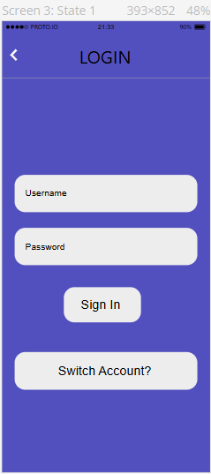 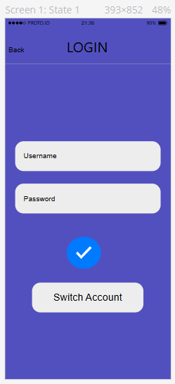

**Result:**

Hence the development of a prototype incorporating both familiar and novel navigation elements has been successfully studied and executed.